1 Data Catalogue

1.1 Driving Profile DATA:

Driving time profile (distance)

1.2 Battery DATA

[Based on best selling MODELS]

|  |  |  |  |  |  |  |
| --- | --- | --- | --- | --- | --- | --- |
|  | sells | battery replacement cost | Battery Capacity | fuel economy | charge/discharge profile | degradation profile |
| Nissan Leaf S  <http://www.electricvehiclewiki.com/Nissan_Leaf> | 85952 | $5,500    url: <<http://www.greencarreports.com/news/1092983_nissan-leaf-battery-cost-5500-for-replacement-with-heat-resistant-chemistry>> | 24 kWh  (100miles)  url: <<http://www.nissanusa.com/electric-cars/leaf/versions-specs/version.s.html>> | MPGe  126 city/101 hwy    url: <<http://www.nissanusa.com/electric-cars/leaf/versions-specs/>> | |  |  | | --- | --- | | 8 hours (EVSE on 240V 40A | ) |   = 12.5miles per hour of charge  url: <<http://www.electricvehiclewiki.com/Charging_System>> |  |
| Tesla Model S  (85) | 55000 | $12,000    url: <<http://www.plugincars.com/tesla-model-s-replacement-battery-packs-125571.html>> | 85 kWh  (265 miles range (EPA))    url: <<http://www.teslamotors.com/models>>    ) | 88 city/ 90 highway MPGe  (38 kWh/100 mile)    url: <<https://en.wikipedia.org/wiki/Tesla_Model_S#Battery>> | 计算机生成了可选文字: 110V / 12 A  1.4 kW  110V / 15 A  1.8 kW  10 kW  5.8 kW  NEMA 5-15  NEMA 5-20  NEMA 14-50  NEMA 10-30  Standard Outlet  Newer Standard Outlet  RVs and Campsites  Older Dryers  VOLTS/ AMPS  KILOWATTS  MILES OF RANGE PER  HOUR OF CHARGE  3  4  29  17  240V /  240V /  40 A  24 A |  |
| BMW i3 | 14000 | $13,725    url: <<https://www.google.ch/search?q=BMW+i3&oq=BMW+i3&aqs=chrome..69i57j69i60j0l4.580j0j4&sourceid=chrome&es_sm=93&ie=UTF-8#q=BMW+i3+battery+replacement+cost>> | 22 kWh  (100 miles the NEDC)    url: <<https://en.wikipedia.org/wiki/BMW_i3>> | 127 city/107 hwy  MPGe    url: <<http://www.caranddriver.com/bmw/i3>> | 5 h 30 min. 230V; AC; 16 A; 3.4 kW, charger install at home(80 %):    6 h 30 min. 230V; AC; 16 A; 3.4 kW, charger install at home(100 %):  url: <<http://www.bmw.com/com/en/newvehicles/i/i3/2013/showroom/_components/calculator.html?calc=charge>> |  |
| Fiat 500e | 12500 | not found | 24-kWh Lithium-Ion    87 miles  EPA    url: <<http://www.fiatusa.com/en/500e/>> | 122 CITY/ 108 highway  MPGe  url: <<http://www.fiatusa.com/en/500e/>> | 4 hrs (240-volt charger installed your home, current unknown)    url: <<http://www.fiatusa.com/en/500e/>> |  |
| Ford Focus Electric | 5600 |  | 23 kWh    url: <<http://www.ford.com/cars/focus/trim/electric/>> | 110 city /99 hwy mpge    url: <<http://www.ford.com/cars/focus/trim/electric/>> | 3.6 hrs (240-volt/30-amp home charging station)    url: <<http://www.ford.com/cars/focus/trim/electric/>> |  |

charge/discharge profile (kWh/s or kWh/h)

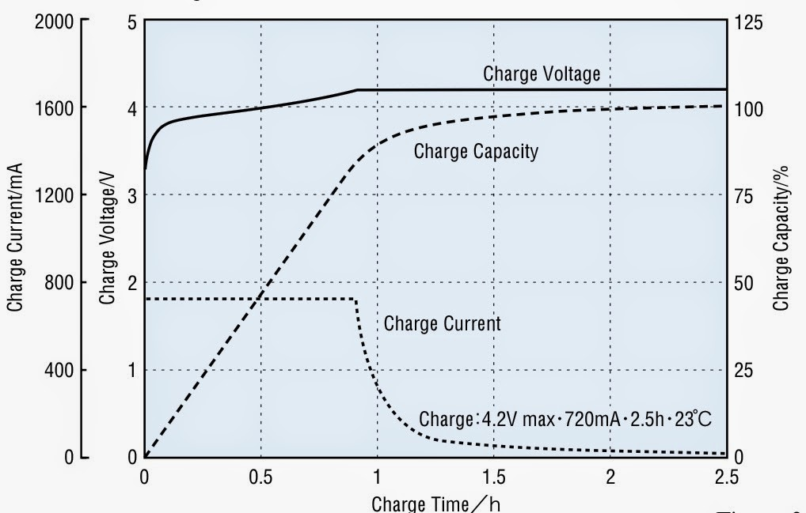

degradation profile (how many days for discharge and charge ele. volume)

Here is a typical battery calendar capacity loss curve for Lithium Manganese batteries plotting Years to End of Life (typically 70% remaining capacity) vs. temperature:

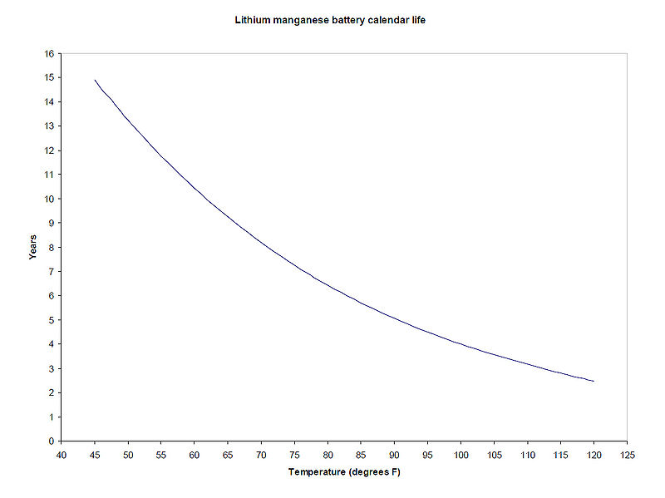

url: <<http://www.electricvehiclewiki.com/Battery_Capacity_Loss>>

A DOD of 80% had made the battery last 3.3 times longer than a DOD of 100% (but remember that the Leaf limits battery use to some extent, [allowing limits of SOC of 95% on the high end and 2% on low end](http://www.mynissanleaf.com/viewtopic.php?f=9&t=5080&p=185571&hilit=soc+2%25#p185571)).

[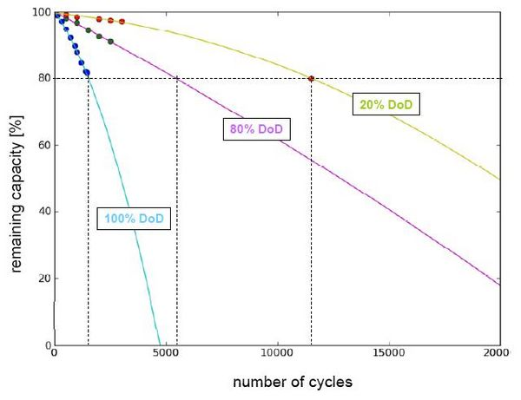](http://www.electricvehiclewiki.com/File:Discharge-curve-KEMA.jpg)

url: <<http://www.electricvehiclewiki.com/Battery_Capacity_Loss>>

Battery Aging Model assumptions:

1. Both calendar capacity loss and cycling capacity loss are temperature dependent
2. Calendar capacity loss is proportional to the square root of time (e.g., 2 years would give 1.41 times the degradation seen at one year, meaning the second year would have 41% of the calendar loss of the first year)
3. Solar loading loss (i.e., parking the car in the sun) was estimated based on a study of the Prius battery ([Media:HEV Battery Life.pdf](http://www.electricvehiclewiki.com/images/4/4d/HEV_Battery_Life.pdf)) and scaled using average annual solar radiation from the NREL:

url: <<http://www.electricvehiclewiki.com/Battery_Capacity_Loss>>

cost

energy consumption(KWh/km)

1.3 Conventional Grid Ele. Price DATA

Under Time of Use rates, you could save money on your electricity bill if you significantly reduce the amount of electricity you use during on-peak times. You will see all the usual charges for Basic Service on your monthly bill, and will also see three new line items. One line item will be your monthly meter charge of $1.50. The other two additional line items will be for your on-peak and off-peak Time of Use adjustments. You will receive a credit for the number of kwh of electricity you used during off-peak hours and an additional charge for the electricity you used during on-peak hours.

Time of Use rate periods:

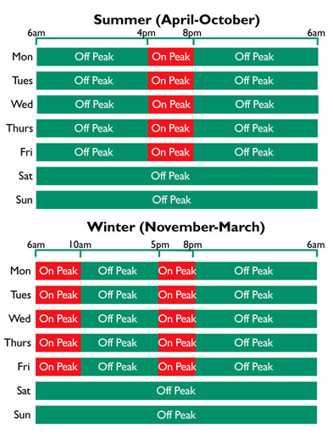

Time of Use rate structure:

|  |  |  |  |
| --- | --- | --- | --- |
| Summer |  | On Peak Charge | Off Peak Credit |
| Residential (per kWh) | Rate schedule 4 | $0.06124 | -$0.01125 |
| Commercial (per kWh) | Rate schedule 23 | $0.09350 | -$0.01438 |
| Irrigation (per kWh) | Rate schedule 41 | $0.08004 | -$0.01231 |

|  |  |  |  |
| --- | --- | --- | --- |
| Winter |  | On Peak Charge | Off Peak Credit |
| Residential (per kWh) | Rate schedule 4 | $0.03316 | -$0.01125 |
| Commercial (per kWh) | Rate schedule 23 | $0.04365 | -$0.01438 |
| Irrigation (per kWh) | Rate schedule 41 | $0.03737 | -$0.01231 |

NOTE: The rates listed above are "adjustments" for Time of Use only. Additional charges for electricity, delivery service (i.e., Distribution and Transmission – see Schedule 4, 23, 41) will need to be added to the supply costs. Remember: Other taxes and applicable charges will also apply.

url: <<https://www.pacificpower.net/ya/po/otou/ooh.html>>